**DACD Lab Experiment -9**

**Due: 19-10-2020**

1. Convert JK flipflop to SR flipflop

|  |  |  |  |  |  |
| --- | --- | --- | --- | --- | --- |
| S | R | Qn | Qn+1 | J | K |
| 0 | 0 | 0 | 0 | 0 | X |
| 0 | 0 | 1 | 1 | X | 0 |
| 0 | 1 | 1 | 0 | X | 1 |
| 1 | 0 | 0 | 1 | 1 | X |
| 1 | 1 | Invalid | | X | X |
| 1 | 1 | Invalid | | X | X |

From K-maps, we get,

S=J & R=K

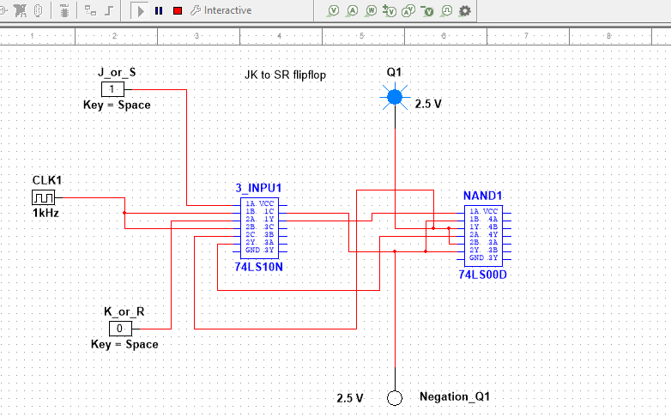

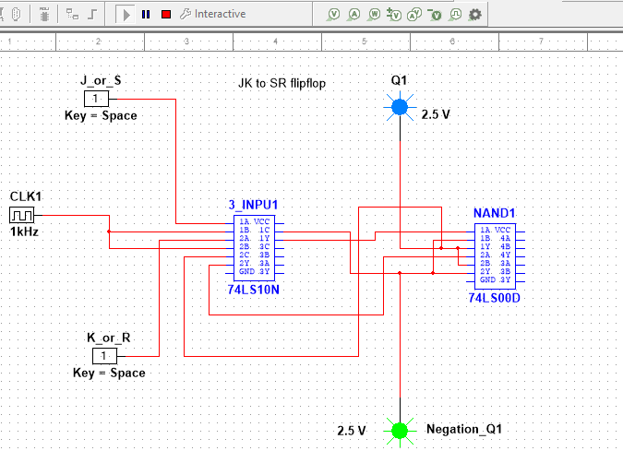

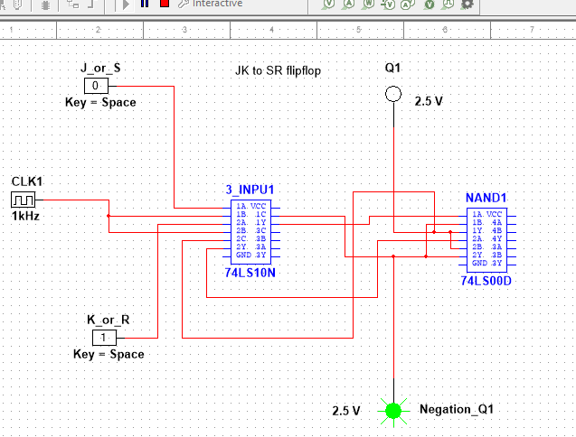

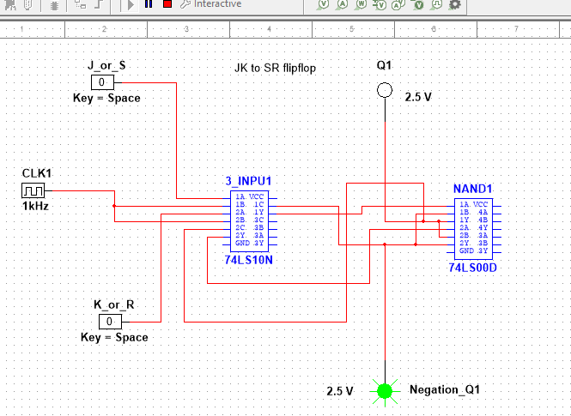

1. Convert JK flipflop to T-Flipflop

|  |  |  |  |  |
| --- | --- | --- | --- | --- |
| T | Qn | Qn+1 | J | K |
| 0 | 0 | 0 | 0 | X |
| 0 | 1 | 1 | X | 0 |
| 1 | 0 | 1 | 1 | X |
| 1 | 1 | 0 | X | 1 |

Using K-maps we get ,

J=T

K=T

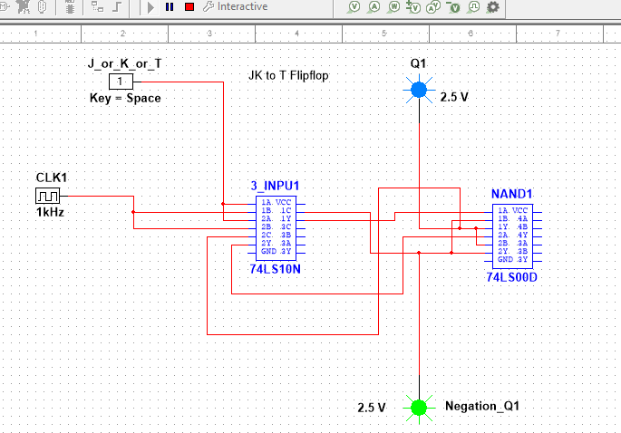

1. Convert JK Flipflop to D flipflop

|  |  |  |  |  |
| --- | --- | --- | --- | --- |
| D | Qn | Qn+1 | J | K |
| 0 | 0 | 0 | 0 | X |
| 0 | 1 | 0 | X | 1 |
| 1 | 0 | 1 | 1 | X |
| 1 | 1 | 0 | X | 0 |

By using K-maps, we get

J=D

K=D’

